**Story**

| Date | 16 December 2024 |
| --- | --- |
| Team ID | 17 |
| Project Name | VoyageVista: Illuminating Insights from Uber Expeditionary Analytics Using Tableau |
| Maximum Marks | 3 Marks |

By using stories in Tableau, you can effectively communicate complex data in a way that is both interactive and engaging, making it easier for the audience to follow along and understand the insights. It’s a tool for **data storytelling**, allowing you to present insights in a cohesive, engaging way that takes viewers through a logical progression of findings or analyses.

In Tableau, **Story** is a feature that allows you to create a sequence of dashboards, visualizations, and text to present data insights in a cohesive and narrative-driven way. It's like a slideshow within Tableau that guides the audience through a series of data points, helping them understand key insights, trends, or outcomes of your analysis.

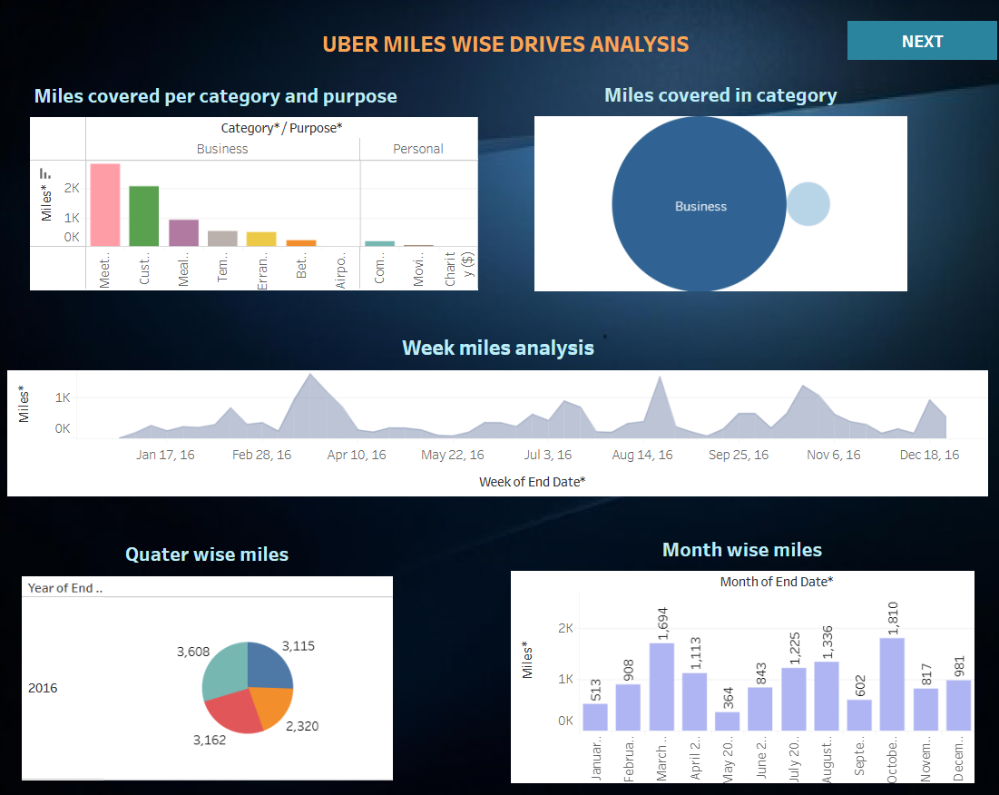

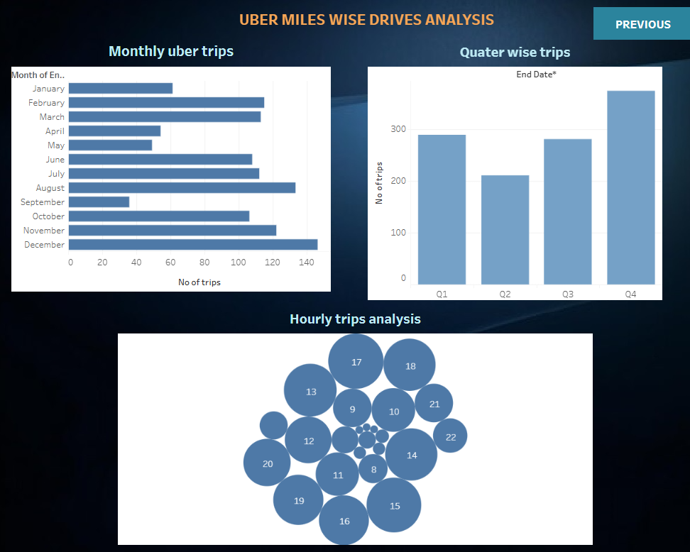

**Observations: -**

**1. Miles Covered Analysis**

* **Business vs. Personal Usage**:
  + **Observation**: The majority of miles covered are categorized as business-related trips. This suggests that Uber is a preferred option for professionals or corporate clients.
  + **Detailed Implication**: This trend indicates that Uber is a significant player in the corporate transportation space. It could present an opportunity for Uber to develop corporate-focused products such as subscription models, business accounts, and partnerships with organizations to offer group discounts for employees. Additionally, this can shape Uber’s branding and marketing toward professionals and business travelers, emphasizing convenience, reliability, and productivity (e.g., rides that allow users to continue working while traveling).
* **Miles by Category and Purpose**:
  + **Observation**: Work-related activities like client meetings, conferences, and team outings contribute to the highest mileage, while personal trips make up a smaller portion of the miles.
  + **Detailed Implication**: Uber could further capitalize on the trend of business-centric rides by crafting specialized services that cater to professional needs. For example, offering vehicles equipped with amenities conducive to work (Wi-Fi, charging stations, quiet cabins) could make Uber the preferred choice for business riders. Uber could also introduce features like meeting point booking or premium vehicles designed for corporate clients.
* **Trend Over Time**:
  + **Observation**: The weekly miles analysis shows periodic spikes in the data, which may indicate fluctuating demand driven by certain events, business cycles, or seasonal factors.
  + **Detailed Implication**: Uber can identify specific weeks or seasons where ride demand peaks (e.g., during conferences, holidays, or fiscal year-end) and plan accordingly. This could involve adjusting surge pricing models, allocating more drivers to high-demand times, or launching special promotional campaigns (e.g., "Conference Week Rides"). Understanding the factors behind these peaks can help Uber optimize its pricing and resource management.

**2. Trip Analysis by Time Intervals**

* **Monthly Trip Distribution**:
  + **Observation**: The highest number of trips occurred in September, suggesting a post-vacation travel surge, likely tied to work resumption after summer breaks.
  + **Detailed Implication**: Uber could take advantage of the post-vacation rush by introducing targeted marketing campaigns aimed at professionals returning to work. Special promotions such as "Back to Work" discounts or loyalty programs could incentivize more frequent usage during this time. Offering faster, more reliable rides during the transition back to work could also boost customer loyalty.
* **Quarterly Trends**:
  + **Observation**: The highest number of trips was recorded in Q4 (October–December), indicating a seasonal increase in demand, possibly due to holidays, end-of-year business travel, or special events.
  + **Detailed Implication**: This seasonal surge presents a prime opportunity for Uber to introduce holiday-specific promotions, such as discounted rides for holiday shoppers or business travelers during corporate events. Uber could also consider adjusting fleet availability during this period to ensure there are enough vehicles to meet demand without significant wait times. Additionally, promotional partnerships with event organizers or businesses during Q4 could further capitalize on increased activity.
* **Hourly Trips Distribution**:
  + **Observation**: The highest activity levels occur in the early morning and evening, which likely correlate with commuting times.
  + **Detailed Implication**: Uber can fine-tune its fleet management and driver dispatch systems to meet peak commuter demand. This could involve setting up incentives for drivers to be available during high-demand hours or introducing commuter-specific services like dedicated “express” rides that focus on getting users to work efficiently. Uber could also consider creating commuter packages offering lower fares during the peak commute hours to attract a steady stream of customers.

**3. Seasonal Trends and Operational Insights**

* **High Business Travel Demand**:
  + **Observation**: The high volume of business-related rides suggests that Uber is not only a commuter service but also heavily used for business purposes, such as meetings and travel between business locations.
  + **Detailed Implication**: Uber has a clear opportunity to expand its corporate partnerships. Offering premium services for corporate users, such as priority bookings, special vehicle options, and VIP customer support, could strengthen Uber’s presence in the corporate sector. Subscription models that cater to regular business users, offering set monthly pricing or bundled rides for specific business categories, could enhance user retention. Furthermore, businesses could leverage Uber's data for tracking employee travel, ensuring they are paying for necessary and efficient transportation.
* **Potential Surge Pricing Windows**:
  + **Observation**: The data reveals distinct windows of peak demand, which could be capitalized on for surge pricing and adjusting resource allocation.
  + **Detailed Implication**: Uber can optimize its surge pricing strategy by closely monitoring these peak periods. For example, identifying patterns in the increase of ride demand during certain times of the day or year can enable Uber to implement dynamic pricing to maximize revenue during high-traffic periods, such as business trips or major events. However, careful implementation is necessary to avoid alienating customers by offering more competitive pricing during periods of peak demand, while ensuring that Uber drivers are adequately compensated.
* **Regional Analysis Possibility**:
  + **Observation**: The dashboard does not currently display geographic data, but the integration of regional insights could enhance the operational efficiency of Uber services.
  + **Detailed Implication**: If Uber integrates geographic insights into the analysis, it could identify regional trends such as demand hotspots, areas with insufficient ride coverage, or regions with a higher concentration of business trips. This would allow Uber to strategically place drivers, optimize route planning, and provide better service to areas with consistently high demand. Additionally, knowing specific regional trends could help Uber to tailor its marketing efforts and improve customer experience in different locations, such as offering city-specific discounts or incentives.

**Activity 2:**

Publish Story on Tableau Public and Paste Public link below

<https://public.tableau.com/views/Uber_project_dash_board2/TripsWiseDashboard?:language=en-US&:sid=&:redirect=auth&:display_count=n&:origin=viz_share_link>